IT490 - Senior Project Summary

Research Methods and Ethics in IT

What is research?
Research is a systematic inquiry that investigates hypotheses, suggests new interpretations of data or texts, and poses new questions for future research to explore.

Why do research?
Research allows us to:
- Pursue new interests
- Confirm or Disconfirm our position on certain issues
- Enhance or Create new products, processes, services and even literature
- Create and learn something new
- Contribute to knowledge

How do we conduct research?
The way we conduct research essentially defines the “methods” or methodology that we follow.
Research methodology is the process used to collect information and data for the purpose of making business decisions.
Research methodology may be quantitative or qualitative.
The methods of data collection will also vary based on the methodology.

Research methods
- Qualitative: Interviews and Observations
- Quantitative: Surveys, Experiments, and Simulations

Research Ethics
Rules for distinguishing between right and wrong.
Moral obligation to act ethically at all times and situations
Be mindful of: Scientific misconduct, Research fraud, Plagiarism, and Avoid harm to research participants

Literature Review and References

What is a Literature Review?
A literature review discusses published information in a particular subject area, and sometimes information in a particular subject area within a certain time period.
This website helps with citing appropriately: http://www.citationmachine.net/

Why write Literature Reviews?
Literature Reviews:
- Serve as a lamp post—as a guide, illuminating your path
- Helpful to know what has been done, how it was done, and the research outcomes
- Determine how different your research is going to be
- Provide alternative direction or paths

Creating your Reference list
Depending on your Professor’s preference, citations may be done in one of the following ways:
- APA (American Psychological Association)
- MLA (Modern Language Association)
- Chicago (The Chicago Manual of Style “CMS”)
- Turabian

Electronic Health Records (EHRs)
In this course, you will be presented with a case study involving the analysis and design of a new information technology application known as an Electronic Health Record (EHR) System.

Requirements
You will be required to:
- Conduct a thorough review of literature on:
  - What is an EHR?
  - The components of an EHR
  - EHR workflow and architecture
- Collect important info for the design of a new EHR system through literature review, case studies, and interviews.

Deliverables
Besides the review of literature that you will be expected to conduct, the following will be provided to you:
- Case study on a hospital that needs to design and implement a new project – the EHR system
- Project challenges and opportunities
- EHR project strategy, goals, and assumptions

What is an Electronic Health Record?
An EHR is a digital version of a patient’s chart. EHRs are real-time, patient-centered records that make information available instantly and securely to authorized users.
While an EHR does contain the medical and treatment histories of patients, an EHR system is built to go beyond standard clinical data collected in a provider’s office and can be inclusive of a broader view of a patient’s care.

Systems Planning

What is your role in the development of a new system?
Your role starts with careful planning:
- Planning requires an understanding of people, process, technology and governance issues
- Study problems and needs of an organization
- Determine best approach to improving organization through use of: People, Methods, and Information technology
- Help system users and managers define their requirements for new or enhanced information systems
- Helps to justify the need for this new or enhanced system

Two Main Activities
- Identification of need (Remember the EHR project)
- Investigation and determination of scope: the EHR components means that there is a lot to cover in terms of design

Systems Strategy
Systems Planning is a part of a bigger Systems Strategy.

Some key questions to ask here include:
- Why is this information system being developed?
- Who are the system’s current and future users?
- Is the system new or an upgrade or extension of an existing system?
- Which functional areas (departments) will be using the system?
Your research should be able to answer all the questions from the previous slides.

Make sure users understand the four W’s:
- Why
- Who
- When
- What

Your research should also examine the following:
- The organization’s strategic goals
- How the proposed system can support these goals
- Which factors are critical to the proposed system’s success
- Criteria for evaluating the proposed system’s performance

The Systems Development Life Cycle (SDLC)

SDLC Methodology
The development of a new software or application typically follows a methodology. A methodology is a series of well-defined phases, performed in sequence, that serve as a framework for developing a system or project.
This is called the Systems Development Life Cycle (SDLC). Each phase’s output (results) becomes the input for the next phase. The initial Planning and Strategy, and to a large extent, the Research you have been working on, are part of the SDLC methodology.
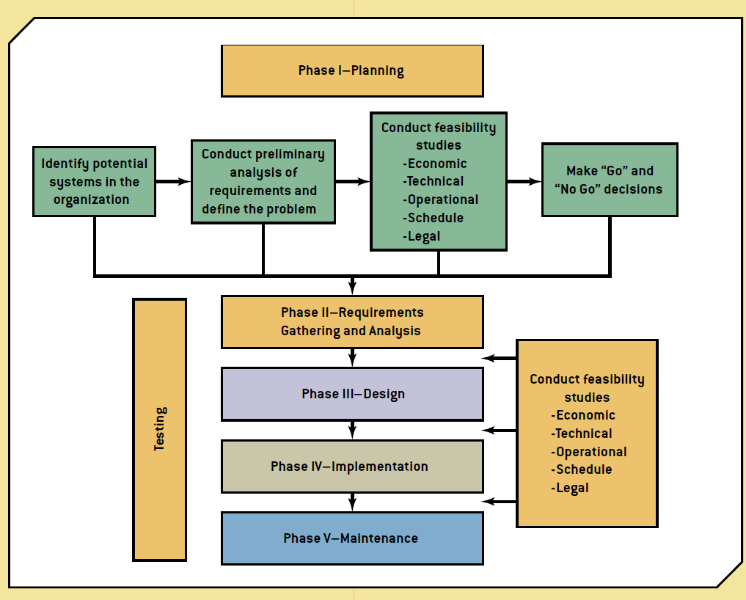

Systems Analysis

Data Requirements
Sometimes in your role as a Systems Designer, you may also be involved in Systems Analysis as part of your Planning and Strategy. In some cases, it’s the same individual functioning in these roles.
Systems Analysis is part of your requirements gathering. In some cases, it’s considered part of your research.

two common approaches
There are two common approaches utilized in the analysis and design of systems:
- Structured systems analysis and design (SSAD) approach
- Object-oriented approach
Involve the use of tools (Unified Modeling Language) for creating analysis models.
The models created during the analysis phase become an integral part of the overall design specifications.

Examples of tools
Examples of tools used can be seen in the table below:

Data flow diagram (DFD)
Analyzes process analysis and design, helps break down a complex process into simpler, more manageable, and more understandable subprocesses; shows how data needed by each process flows between processes and what data is stored in the system; it also helps define the system's scope.

Flowchart
Analyzes process analysis, illustrates the logical steps in a process but doesn't show data elements and associations; it can supplement a DFD and help analysts understand and document how a process works.

Context diagram
Analyzes process analysis and design, shows a process at a more general level and is helpful for showing top management and the task force how a process works.

Conceptual data model (i.e. entity relationship model)
Analyzes data analysis, helps analysts understand the data requirements a system must meet by defining data elements and showing the associations between them.

Workflows
Workflows allow you to present key requirements of your new software based on: inputs, processes, and outputs
The software inputs data which is often processed into information.
Understanding data requirements and mapping this using a Unified Modeling Language (UML) is necessary.

Example of a dfd
Example of a data flow diagram capturing data in an inventory management system:
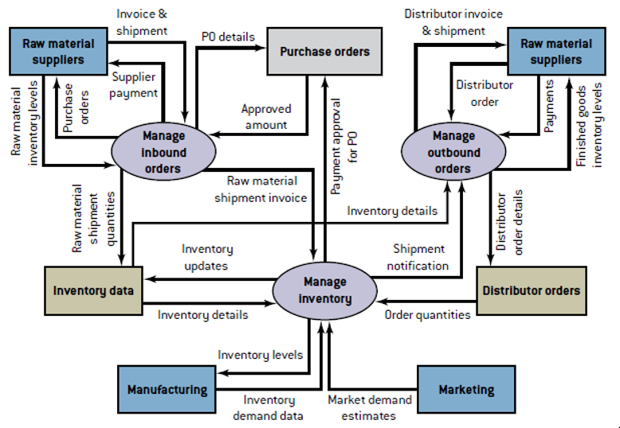

Conceptual Modeling
The data flow diagram captured the data requirements and flow. However, it does not capture the detailed relationship between the data elements flowing through the system or software.
The conceptual data model will eventually be translated into a physical design. One of the key deliverables at this stage is the entity-relationship diagram.
The conceptual data model shows the relationship between the data flows from one entity to another.
The conceptual data model can be easily created using Microsoft Visio as a tool.

A sample Conceptual data model:
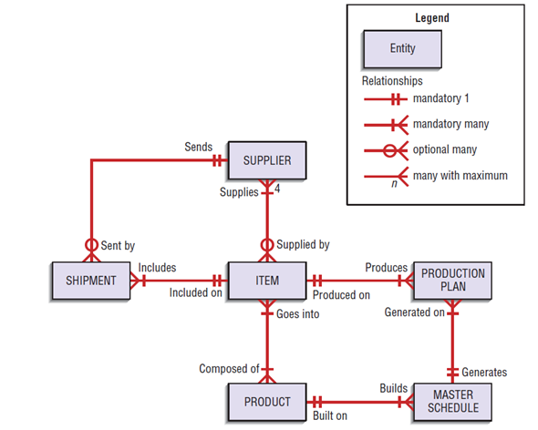 | 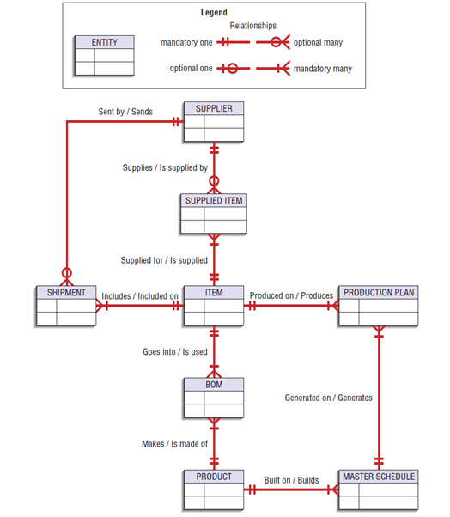

Logical Requirements
The Design phase follows the Analysis phase of the SDLC, where analysts choose the solution that’s the most realistic and offers the highest payoff for the organization.
A good human-computer interface provides a unifying structure for finding, viewing, and invoking the different components of a system.
Focus on how information is provided to and captured from users

Output of this phase
- Document with exact specifications for implementing the system
- Includes files and databases, forms and reports, documentation, procedures, hardware and software, networking components, and general system specifications

Design phase includes:
- Logical design: Conceptual details including workflow and interfaces for data and processes
- Physical design: Hardware and platform requirements are addressed

When structuring data entry, consider the following:
- Entry: Never require data that are already on-line or that can be computed
- Defaults: Always provide default values when appropriate
- Units: Make clear the type of data units requested for entry
- Replacement: Use character replacement when appropriate
- Captioning: Always place a caption adjacent to fields
- Format: Provide formatting examples
- Justify: Automatically justify data entries
- Help: Provide context-sensitive help when appropriate

Physical Requirements

Physical Design
The results of logical data design require that you make some key decisions, such as:
- Choosing storage format for each attribute from the logical database model
- Grouping attributes from the logical database model into physical records
- Arranging related records in secondary memory (hard disks and magnetic tapes) so that records can be stored, retrieved, and updated rapidly
- Selecting media and structures for storing data to make access more efficient

Another important decision to make
- Will you be storing your data in-house or using a cloud host service?
- Do you have a server on-site?
- How will you protect your data?

Business and Technical Requirements (BTR)

General Information
The BTR document provides and presents all of the information that is required to plan and design your new information system. Most of the information in the document should have been identified and possibly created throughout the course.
The document includes:
- The purpose of the project.
- Project References
- Acronyms and Abbreviations
- Points of Contact

Current System Summary
The Current System Summary includes:
- Background: This is the project background. It provides a summary of the entire application being designed.
- System Objectives and Current Functionality: An itemized list of objectives and expected functionalities are identified here.
- Current Methods and Procedures: Current Equipment, Input and Outputs to the system, and any Deficiencies that need to be addressed are noted here.

Proposed System
The Proposed System includes:
- Summary of Improvements.
- Improvements in functionality, existing capabilities and timelines are noted here.
- Summary of Impacts.
- Impacts of the proposed system to organizational users and operations are noted.
- Assumptions and constraints are also documented.
- Detailed characteristics.
- Details of functional and proposed system functions are presented here, including any potential factors that may hinder project success.
- Design considerations.
- Flow charts depicting system and functional descriptions are presented.

Presentation
The slides that follow should be used as a Presentation Guide for Business and Technical Requirements document.
- Purpose
- Share with the audience the purpose of the research.
- Present your research (data) sources.
- Current System
- Describe the problems with the current system and how they have impacted the organization.
- Describe input, process, and output issues as they related to data and information.
- Proposed System
- Describe your proposed solution.
- What new functionalities do you plan to introduce?
- How will these impact the organizational users and operations?
- Proposed System Design
- Include flow charts of your new system.
- Be ready to briefly discuss it.
- What assumptions did you make in your overall design?
- Lessons learned
- What did you learn the most about the project?
- Briefly list these, and be ready do share with your audience.

Source: What is research? (n.d.). Retrieved March 10, 2015, from http://urp.ucsd.edu/for-students/what-is-research.html
Source: What is research methodology? definition and meaning. (n.d.). Retrieved March 10, 2015, from http://www.businessdictionary.com/definition/research-methodology.html
Source: Literature Reviews. (n.d.). Retrieved March 10, 2015, from http://writingcenter.unc.edu/handouts/literature-reviews/
Source: https://owl.english.purdue.edu/owl/resource/
Source: "HealthIT.gov." What Is an Electronic Health Record (EHR)? Accessed March 11, 2015. http://www.healthit.gov/providers-professionals/faqs/what-electronic-health-record-ehr
Source: Bidgoli, H. (2014). Building Successful Information Systems. In MIS⁴ ([4th ed., p. 336). Boston: Course Technology.
Source: Bidgoli, H. (2014). Building Successful Information Systems. In MIS⁴ ([4th ed., p. 336). Boston: Course Technology
Source: Bidgoli, H. (2014). Building Successful Information Systems. In MIS⁴ ([4th ed., p. 336). Boston: Course Technology
Source: Valacich, J., George, J., & Hoffer, J. (2015). Systems Planning and Selection. In Essentials of Systems Analysis and Design (6th ed., p. 418). New Jersey: Pearson.
Source: Valacich, J., George, J., & Hoffer, J. (2015). Systems Planning and Selection. In Essentials of Systems Analysis and Design (6th ed., p. 418). New Jersey: Pearson.
i.e., design of a new EHR system to better capture patient information throughout the patient life cycle
I.e., what you are trying to achieve
E.g. Analyzing interviews, literature reviews of articles, white papers, etc
Refer to your research findings

